  - ENEMLOS NEWSLETTER Issue 4/2022
October/November/December 2022
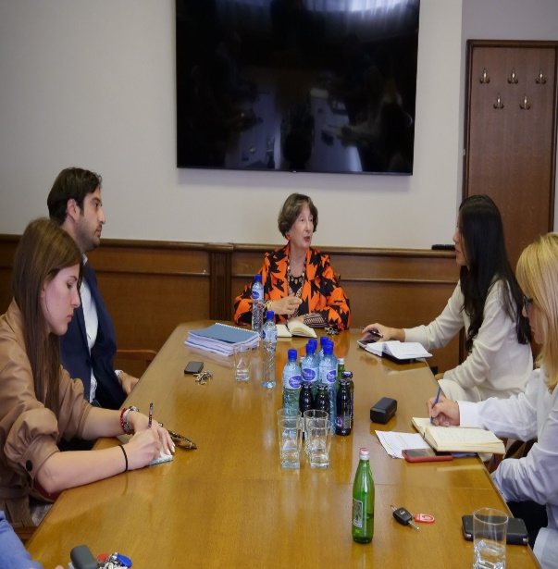 |  |  |  | LEGAL CLINICS IN SERVICE OF VULNERABLE GROUPS: ENHANCING THE EMPLOYABILITY OF LAW STUDENTS THROUGH PRACTICAL EDUCATION  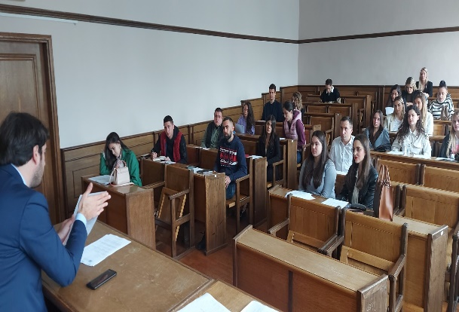  - In This Issue:
TTTTProject management team of the project ENEMLOS on October 19, 2022, was held at the Faculty of Law with representatives of the judiciary participating in the ENEMLOS project: the Supreme Court, the Supreme State Prosecutor's Office, the Bar Association of Montenegro , the Chamber of Notaries, the Chamber of Public Executors, and the Center for ARS. |  | nn
–––––––
 |  |  |  |  | Student training at Faculty of law Podgorica
.

.
Meeting at the Supreme court of Montenegro
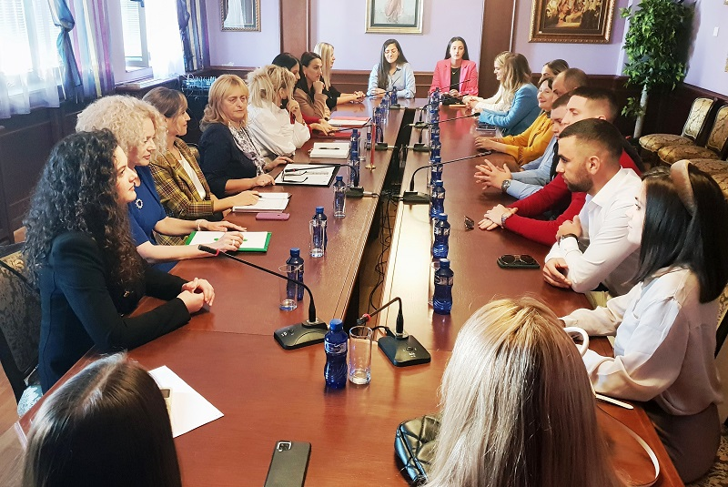
SECOn December 6, 2022, the second meeting of the mb
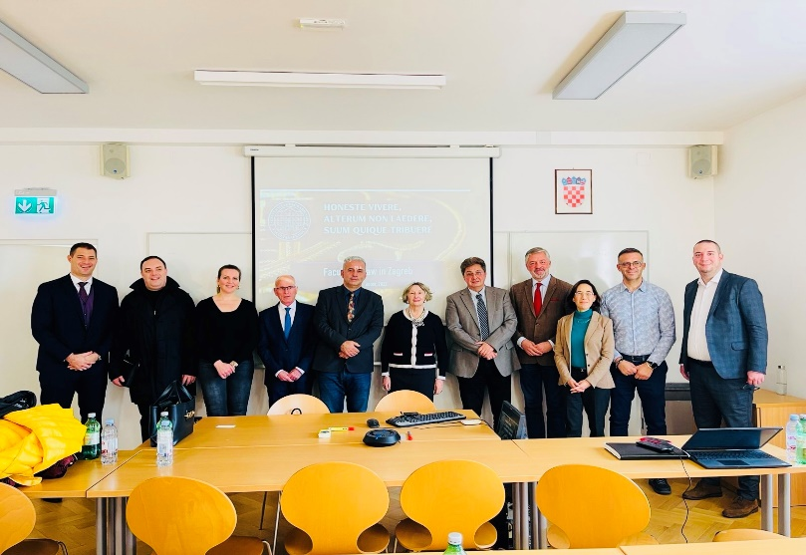
QB MEETING AT Faculty of law Podgorica
